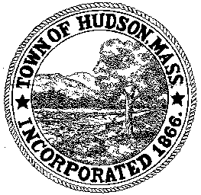

BOARD OF HEALTH
78 Main Street
Hudson, MA 01749
(978) 562-2020
Meeting Agenda
August 28, 2012
7:00 PM

- Preliminaries
1.1 Open Meeting
1.2 Roll Call

2.0 Application for Body Art Practitioner
Applicant: Andrew Russell

3.0 Housing Complaint
3.1 89 Broad Street Housing Code Violations

4.0 Reaffirmation of July 24, 2012 Votes
4.1 89 Broad Street – Housing Complaint
4.2 Ernie’s Excavating Installer Application
4.3 175 White Pond Road Septic Plan
4.4 BOH Vouchers
4.5 Minutes June 26, 2012

5.0 Application to Install Subsurface Sewage Disposal System
5.1 28 Murphy Road

6.0 General Business
6.1 Fee Schedule Revision
6.2 Substance Abuse Grant update
6.3 West Nile Virus update
6.4 Minutes – July 24, 2012 and August 14, 2012
6.5 Voucher – BOH082812 $980

7.0 Adjournment

Next Meeting: September 11, 2012

